Table of Contents

Introduction 2

Login 2

Browser 2

Security 3

Employee Home 3

Employee Home Navigation 3

1. Global Navigation Bar 4

2. Employee Home Navigation Bar 4

3. Dashboard 5

4. Some Useful Links 5

5. Additional Tabs 5

Institution Selection 6

Dashboard 6

My Profile 6

Personal Information 7

Contact Information 8

Emergency Contact Information 8

Retirement Plan Participation History 8

Faculty Pay Option 9

I-9 Information 11

Work Experience 13

Education 14

Steps to add Major/Minor and Educational Emphasis 16

Add Courses 17

Professional Licenses/Certificates 19

College (MSCF) Faculty Submit for Evaluation 20

MSCF Evaluation Email Notification 20

MSCF Evaluation Results 20

MSCF Evaluation History 21

My Jobs 22

My Settings 23

Supervisor Functions 23

Supervisor View 24

Manage Employee Appointments 24

Manage Temporary Faculty Employment (for supervisors of faculty only) 24

Delegate Authority 25

Upcoming Events 25

Log Out 25

Tips for using Employee Home 25

Additional Documentation 26

Need Help? 26

Introduction

The Employee Home application allows an employee to access employee applications such as eTimesheet, Security Administration and Tuition Waiver. In addition, functionality is available that will allow employees more visibility into their employment with Minnesota State Colleges and Universities. Employee home also gives an employee access to Administrative Applications for which they have been granted security access, such as Accounting, FWM, or Curriculum Management. The list of Administrative Applications will vary depending on your security role, and the institution.

Login

**The URL for Employee Home is** <https://eservices.minnstate.edu/employee/public/secure>

Browser

For optimal browser performance use Firefox, Chrome or Safari. Do not use Internet Explorer as many ISRS applications will not open or display properly if Internet Explorer is used. If your default browser is Internet Explorer, copy and paste the above URL and use one of the other browsers.

Security

Your security access to Employee Home is based on your current employment status as an employee of Minnesota State. If you need a security role that does not appear in the Administrative Applications list, refer to the [Security Administration Application Documentation](https://mnscu.sharepoint.com/sites/isrsproducts/SitePages/Groups.aspx?Group=Security%20Administration) (Login using your [StarID@minnstate.edu](mailto:StarID@minnstate.edu) required) for details on how to request security.

Employee Home

When you log in with your StarID and password, you will land on the Employee Home screen. The Employee Applications list provides a list of applications that are based on your status as an employee at an institution. The Administrative Application list is customized based on the applications to which you have access based on your position at an institution. The following list is an example; your list will likely be different.

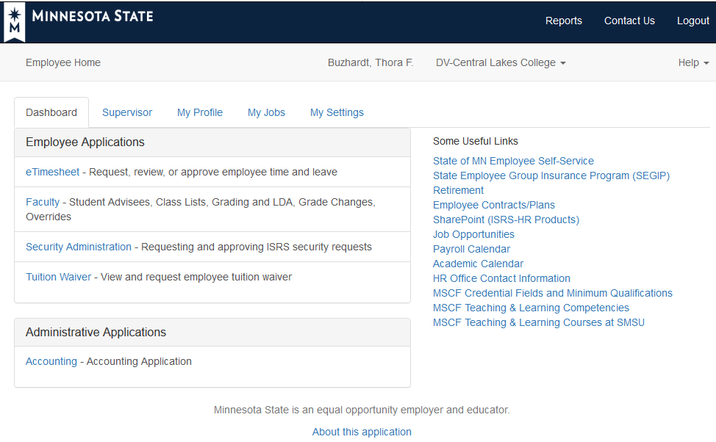

Employee Home Navigation

Employee Home is a tabbed form that allows you to access much of your employee information via the various tabs and links. If there is missing personal, contact, education or experience information in your record, you will see a message at the top of the screen until the information has been entered.

The numbered guide below provides information about each section on the Employee Home page.

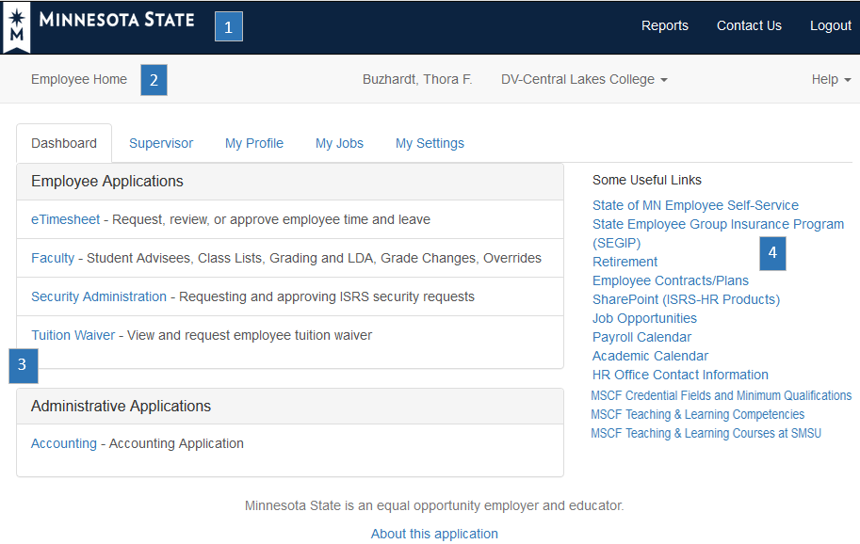

1. Global Navigation Bar
2. Reports will allow you to generate, view and print system reports that you have access to request.
3. Contact Us will bring you to a new window where you may submit a Service Desk request.
4. Logout will log out your session and bring you to the StarID login page.
5. Employee Home Navigation Bar
6. Your name will be displayed in the Employee Home navigation bar. If you have submitted a preferred name to your Human Resources office, your preferred name will be displayed throughout Employee Home.
7. The institution that is currently accessed will be displayed. If more than one institution is available, there will be a dropdown arrow to the right of the institution name. See the *Institution Selection* section below for more information.
8. Help will allow you to access User Guides and the IT Service Desk.
9. Dashboard

* **Employee Applications-Dashboard -** A list of applications that are based on your employment with an institution.
* **Administrative Applications -** If you have access to administrative applications, they will show up under this heading.

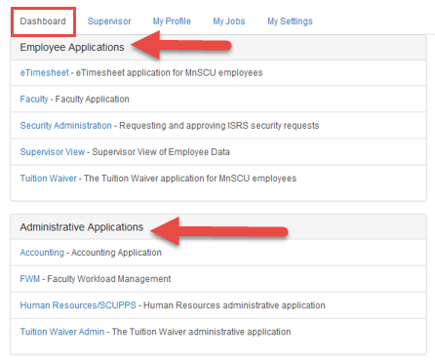

1. Some Useful Links

Links to State of Minnesota sites and other frequently accessed employee sites.

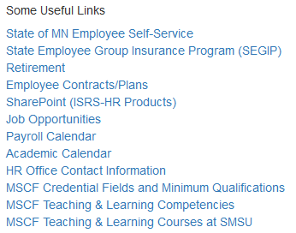

1. Additional Tabs

* **My Profile** **tab** will allow you to view and in some cases update Profile information which includes personal information, contact information, work experience and education.
* **My Jobs tab** will provide you with employment information which consists of bargaining, appointment and salary information.
* **My Settings tab** allows you to set a default institution if you have a relationship with one or more Minnesota State institutions. You may also set a default ISRS printer and access a link to update your StarID password under My settings.
* **Supervisor tab -** If you are a supervisor at the institution selected, you will also have a Supervisor tab. See the ***Supervisor Tools Quick Resource Guide*** for information on additional functionality available to supervisors.

Institution Selection

* If you have a relationship with more than one institution, access to applications at other institutions is available by changing the Institution in the top Employee Home Navigation bar.
* If you have not set a default institution, the institution that is active will be the one that is first in alphabetical order by institution.
* The Active institution determines the applications displayed in the Employee Applications and Administrative applications. If you do not see the expected applications, please try to change institutions. See the ***My Settings*** section below for steps on setting or changing the default institution.

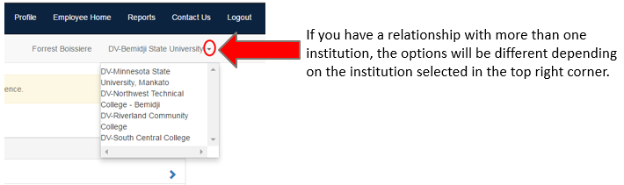

Dashboard

The Dashboard tab allows you to access to Employee Applications and Administrative Applications as well as your Profile, Jobs, and Settings tabs.

My Profile

The My Profile section in Employee Home allows you to review and in some instances update your demographic information. Below is an outline of each section:

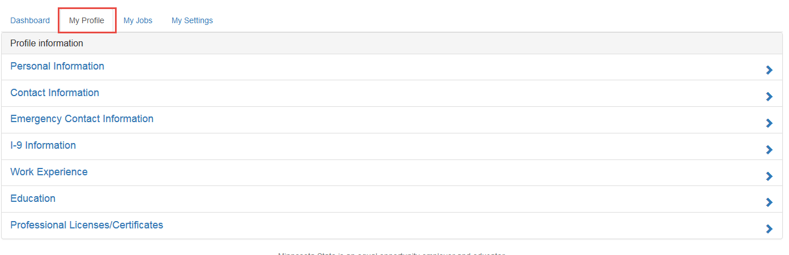

Personal Information

Personal information includes information that is currently part of your Human Resources record. This information includes: Name, SSN (last 4 digits), Birth Date, Citizenship, Title (if applicable) Gender, Marital Status, Race and Ethnicity, Disability, and Veteran Status. Fields that may be modified will appear with dropdown selections or check boxes. Once you have modified your record, you must Save any changes you make to this information.

**NOTE:** Changes to legal name, social security number, birth date and citizenship must be made by your institution HR office upon receipt of proper legal documentation. If you have a preferred name that you would like to use instead of your legal name, you must submit that request to your institution Human Resources office.

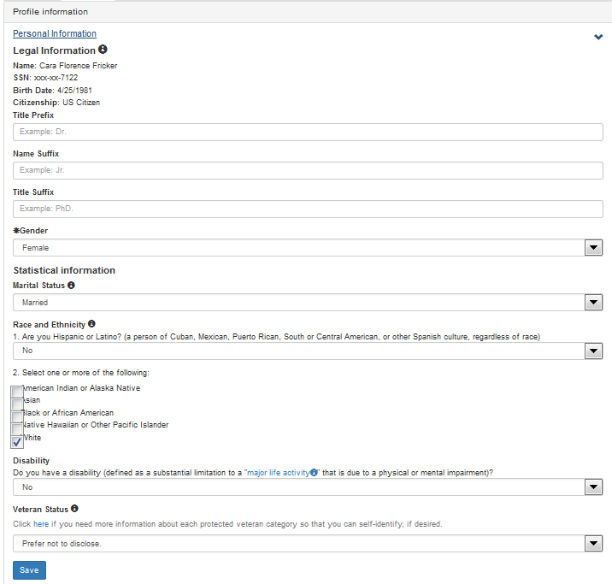

Contact Information

The contact information tab allows you to review and update personal contact information. Items with an asterisk * are required fields. Information includes Personal Email, Home Phone, Mobile Phone, Country, Street 1, Street 2, State, City, Zip, Zip suffix, and County. If you make any additions or modifications to this information, you must save the information.

If a change is made to your state of residency, the following message will appear.

*This change in state of residency requires an update to your state tax data in the* [*State of Minnesota Self-Service*](http://www.state.mn.us/employee) *system. If you have any questions, please contact your payroll office.*

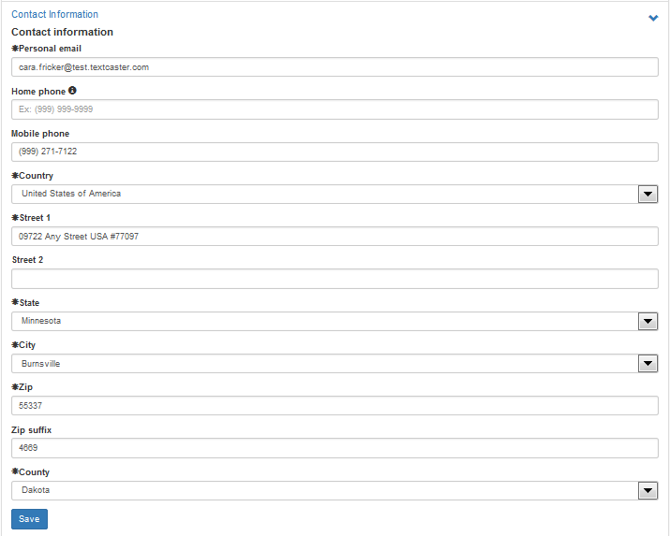

Emergency Contact Information

The Emergency Contact Information tab will allow you to provide one or more emergency contacts. You may add an emergency contact name, primary and secondary phone number and if you have multiple contacts listed, you can indicate which one is the primary contact.

Retirement Plan Participation History

The Retirement Plan Participation History tab allows you to provide required information about retirement plans in which you have had service, taken a distribution, or are currently receiving an annuity. If you are required to complete this information, you will be prompted with this message when you login to Employee Home.

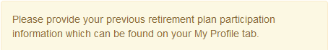

See the [Automated Retirement Checklist User Guide](https://mnscu.sharepoint.com/:w:/r/sites/isrsproducts/_layouts/15/Doc.aspx?sourcedoc=%7BA02081EE-5A51-4F10-9C90-48043A425114%7D&file=Automated%20Retirement%20Checklist%20User%20Guide.docx&action=default&mobileredirect=true) for additional details.

Faculty Pay Option

Eligible faculty may elect to have their primary assignment pay distributed over a 9 month or a 12 month period. If you are in an eligible faculty position the Faculty Pay Option section will display under the My Profile tab.

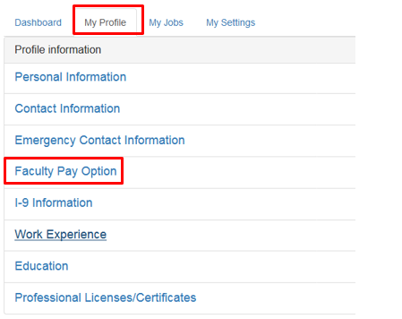

For all faculty hired before October 5th, 2017 your Faculty Pay Option will be set to match your current pay from the HR system. For those hired on or after October 5th, 2017 your Faculty Pay Option will default to a 12 – Month Pay Option. To make a change to your pay option select the “Add Faculty Pay Option” button. This will open the following window.

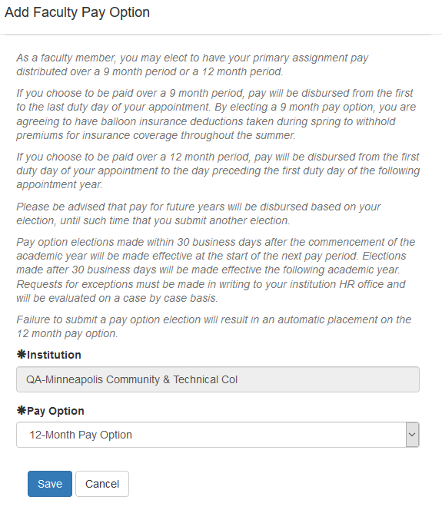

Select the institution, Pay Option and then click save. Existing records cannot be updated or deleted.

**NOTE:** Please be advised that pay for future years will be disbursed based on your election, until such time that you submit another election. Pay option elections made after the commencement of the academic year will be made effective the following academic year. Requests for exceptions must be made in writing to your institution HR office and will be evaluated on a case by case basis. Failure to submit a pay option election will result in an automatic placement on the 12 month pay option.

I-9 Information

After an employment offer has been made and accepted all **new** employees must provide employment eligibility information via Federal form I-9 (Employment Eligibility Verification). An existing employee may also be prompted to complete a new I-9 upon rehire or expiration of verification documents. If an existing employee attempts to complete a new I-9 form and there is already one on file, the following message will be displayed:

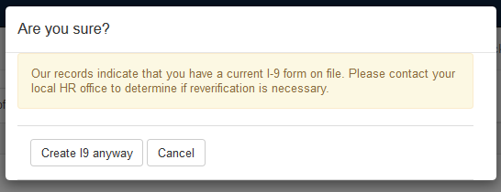

Section 1 of this I-9 form is to be completed by the employee. Section 2 will be completed by Human Resources, printed, signed by the employee and the reviewer, and filed in Human Resources. The verification (Section II) process is automated for Human Resources processing.

Here are the steps to complete the I-9 Form:

1. Select I-9 Information on the ***My Profile tab***.
2. Click on *Add Employee Work Eligibility Status*.
3. An *Employee Work Eligibility Status* page displays. Read all instructions carefully before entering information on this page[. Additional instructions can be found at this link on the page: I-9 Instructions for Employee](https://www.uscis.gov/sites/default/files/files/form/i-9instr.pdf).
4. Include Other Last Names Used if applicable and select a Citizenship Status from the drop-down list. Depending on the Citizenship Status selected, you may need to enter additional information such as Alien Registration Number/USCIS Number, Foreign Passport Information, or I-94 Admission Number.
5. Click on Accept.

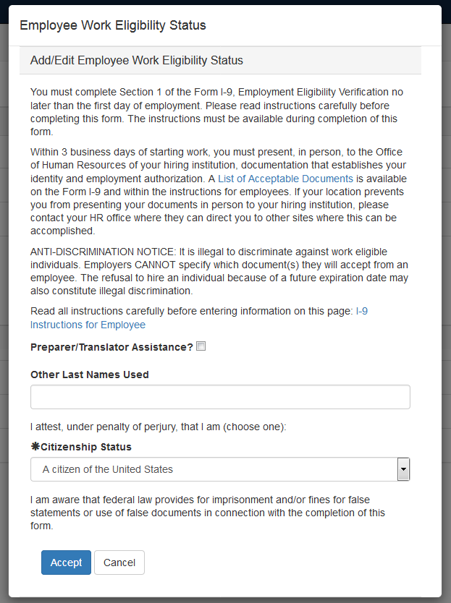

1. When you click *Accept*, the I-9 form will be stored.

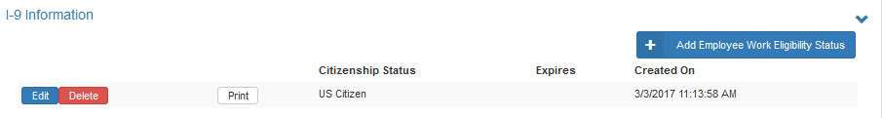

1. You must print the pdf form that is generated with your information by going to the Print option, and once you have reviewed the information, print all pages from the browser. You may also download this pdf using the browser download option.
2. You must provide this printed form along with supporting documents to the hiring institution Human Resources office no later than the first day of employment, but not before accepting the job offer.

Note: If one of the following statuses is selected:

* An alien authorized to work – Alien Registration/USCIS
* An alien authorized to work – I-94 Admission
* An alien authorized to work – Foreign Passport

The below message will display:

*In order to determine and document your resident or nonresident status for tax purposes, tax withholdings, and any tax treaty benefits you may be eligible to receive, please complete, print and return the*[*Payroll Tax Residency Information Form*](http://www.minnstate.edu/system/finance/taxinformation/nonresident/nra_facultyandstaff/docs/taxres_form_ee-%20fill%20in.pdf) *to your institution HR office. You are not legally required to complete this form, but if you do not do so, we will be unable to determine your eligibility. If you have any questions regarding this form, please contact your institution HR office.*

Once Human Resources has verified an I-9, the status will change to verified, and you will no longer have the ability to edit or delete the I-9 form.

Work Experience

Work experience outside of Minnesota State may be added and maintained for all employee groups in the Work Experience section. For college (MSCF) faculty this information will be used to establish salary placement or adjust a salary placement as applicable and ensure minimum qualifications for the faculty role have been met. You may choose to Add new work experience outside of Minnesota State or select “I have no work experience outside of Minnesota State” by clicking on the appropriate link.

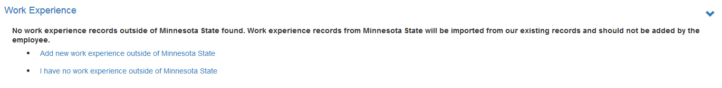

If you select to add new work experience outside of Minnesota State, a new form will open for you to complete. Items with an asterisk * are required fields. Information presented includes Work Experience Type, Academic Rank, Employer Type, Employer Name, Work Title, Start Date, End Date and Percent of Full-Time. Select the appropriate details from the dropdowns for each section. If an academic Work Experience Type is selected you must select an Academic Rank. After the entry is complete, save the information.

NOTE: Prior work experience for Minnesota State regardless of level will be imported to your institution evaluator to apply to salary and/or minimum qualification determinations as applicable.

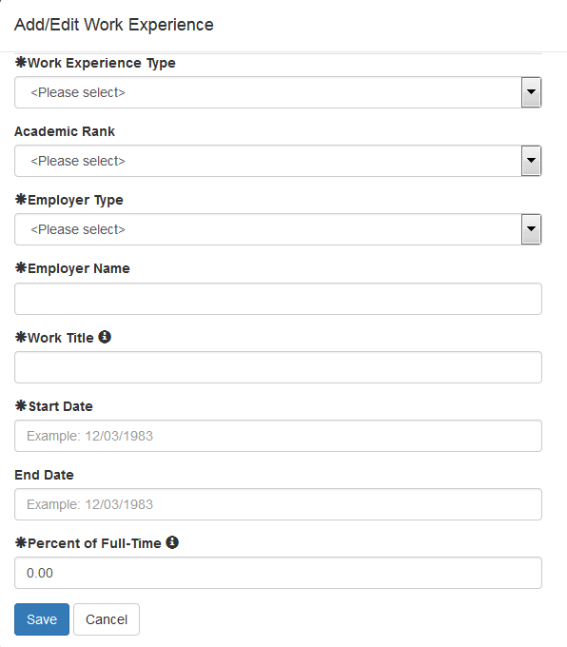

The entry that was saved will then appear under Work Experience. After a record is saved you may choose to edit or delete the record. Once Human Resources has verified the entries, you may no longer edit or delete these records.

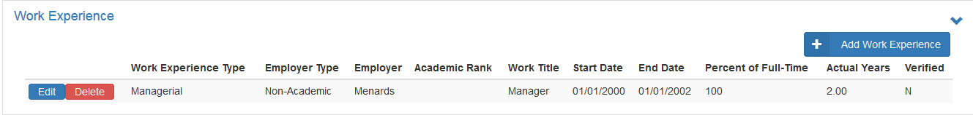

Education

Educational information may be added and maintained for all employee groups. For college (MSCF) faculty this information will be used to establish salary placement or adjust a salary placement as applicable and ensure minimum qualifications for faculty role have been met. You may choose to “Add new education” or select “I have no education information to report.”

Select **Add new education**. If you have completed Minnesota State Degrees a window will appear asking if you would like to import your Minnesota State degrees into your employee profile.

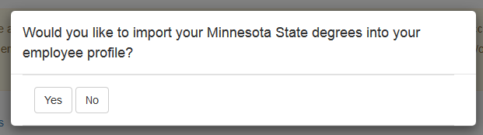

If “Yes” is selected all Minnesota State degrees that have been completed will display.

If “No” is selected an Institution Search box will appear.

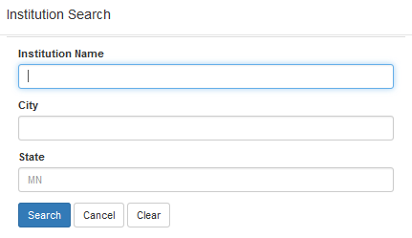

Once you select an institution, a data completion box will appear. Degree and Course data will include:

* Academic Institution
* City and State
* Name of Institution as it appears on the transcript
* Foreign Institution?
* Date Degree Conferred
* Degree
* Name of Degree

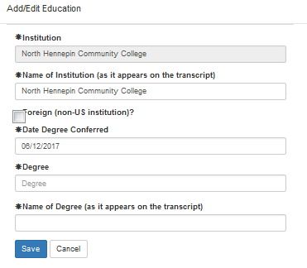

Click on Save when entry is complete.

*Items preceded with an asterisk are required fields.

Steps to add Major/Minor and Educational Emphasis

Majors and Minors, and Educational Emphasis may be added once the Education record has been saved.

1. To add Major/Minor information, select **Add** **Majors/Minors** to the right below degree information.
2. Enter Degree Major/Minor which includes:

* Select either Major or Minor
* Major/Minor Name
* Name of the Major/Minor (as it appears on the transcript)
* Date Major/Minor was Conferred

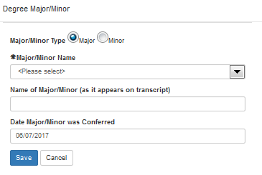

* Items preceded with an asterisk are required fields.

Once all data has been entered, Save the record.



The Major/Minor will then display in the list and you will have the option to enter an Emphasis. Enter the Degree Emphasis as it appears on the official transcript.

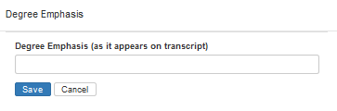

If modifications are needed after saving a record, click on the edit button to edit a saved record. Once Human Resources has verified the entries, you may no longer edit or delete these records.

Add Courses

To add relevant course information, select **Add Courses** under the Courses Tab. If you have Minnesota State courses a window will appear asking if you would like to import your Minnesota State courses into your employee profile.

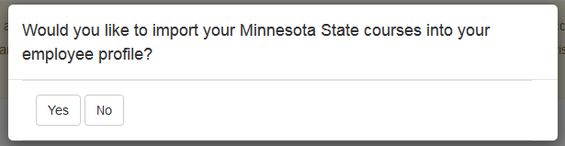

If “Yes” is selected all Minnesota State courses that have been completed will display.

If “No” is selected an Institution Search box will appear.



Enter institution search information and select the institution. The institution name will then be pre-populated on the course information data screen. See the example on the next page.

Course Information will include:

* Subject/Prefix
* Course Number
* Title,
* Year, Term and Term Type
* Actual Credits
* Semester Credits (Actual Credits/1.5)
* Undergrad or Grad Level

* Items preceded with an asterisk are required fields.

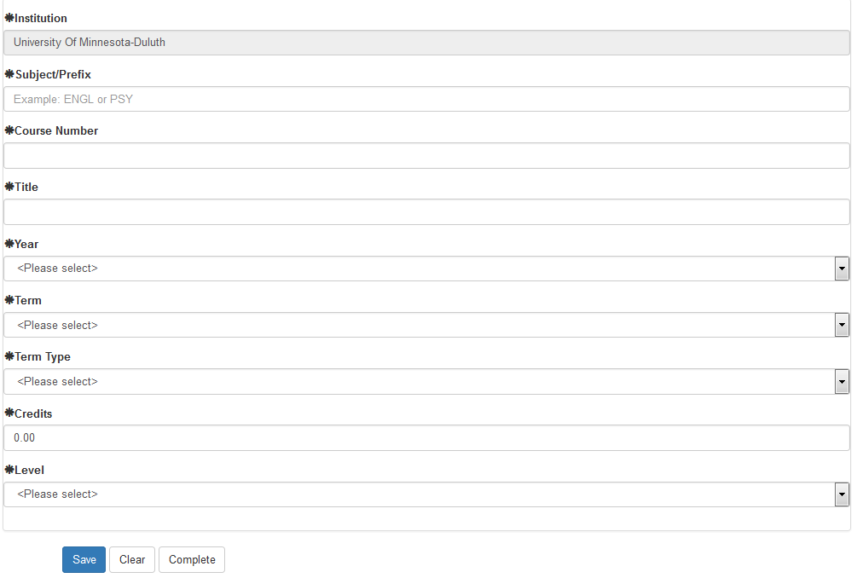

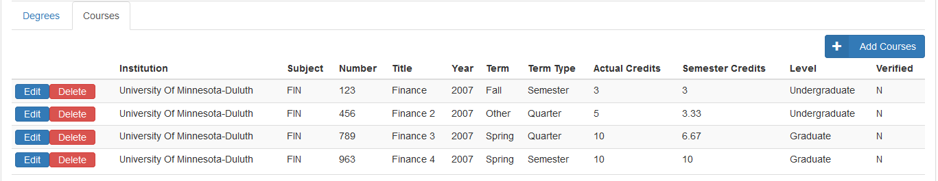

Once all data has been entered, Save the record.

Since you will likely have multiple course entries for a single institution, after you save the first course, several fields will now default with values from your previous entry as you enter subsequent courses. This will reduce data entry and provide you with the ability to enter a number of similar courses from the same institution more efficiently.

Saved course information will be listed at the bottom of the screen.

When you have finished saving all courses from one institution, click on the Complete button to return to the Education heading to continue on with your entry of additional courses.

If modifications are needed after saving a record, click on the edit button to edit a saved record.

Once Human Resources has verified the entries, you may no longer edit or delete these records.

Professional Licenses/Certificates

Employees have the ability to add or update professional certificates/licenses that are relevant to employment at Minnesota State. This credential information may then be used to ensure minimum qualifications of the position have been met. College (MSCF) faculty hired in a discipline/program area for which a license or certification is a minimum qualification requirement must enter this information for evaluation. Please refer to the ***College*** ***Faculty Salary & Credential Entry QRG*** for additional information on completing this section.

Select the **Add Certificate License** button on the right side of the section. You may add, edit or delete professional licenses and certificates in this section.

Certificate and License data will include:

* Type-Select Certificate or license from the drop-down
* Title
* Grantor
* Grantor Country
* Grantor State
* Grantor City
* Date Issued
* Expiration Date

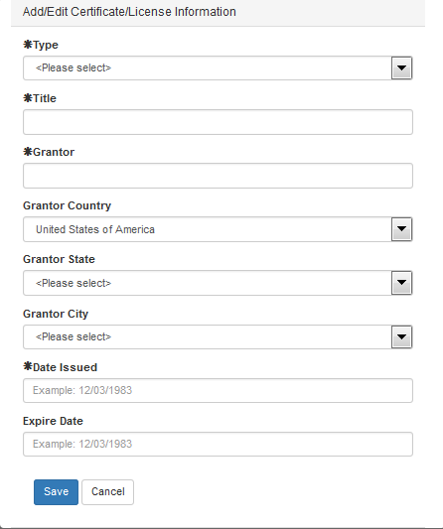

* Items preceded with an asterisk are required fields.

Once you have completed the entry, click on Save. You may then enter additional licenses or certificates. You may also edit or delete existing entries if necessary and if they have not been verified and evaluated.

College (MSCF) Faculty Submit for Evaluation

After completing entry of all credentials, verify that the information is correct. You may then click on the **Click Here** button on the top of the Employee Home page to submit the credentials for evaluation.



This will prompt the college evaluator to review and evaluate submitted information. Information submitted for evaluation will require official documentation to support your credential data, i.e. an official transcript and/or work experience verification forms and if applicable license/certification documents.

NOTE: Once your submitted information has been verified you will no longer be able to modify your records. If you have additional information that is not already listed, you will be able to return to these sections to make additional entries.

MSCF Evaluation Email Notification

Email notifications are automatically sent to certain recipients depending on the type of evaluations. All [template emails](https://mnscu.sharepoint.com/sites/isrsproducts/SitePages/Topics.aspx?Topic=Credentialing) can be found in SharePoint under Topic -> Credentials and document type -> Communication.

**Recipient List**

* Salary Placement - faculty member, campus HR, system office and MSCF union
* Minimum Qualifications - faculty member, campus HR and system office
* TLC Requirements – faculty member, system office and campus HR

MSCF Evaluation Results

Credential evaluation results may be reviewed by going to the My Jobs tab, then select Evaluations. The evaluation decision for Minimum Qualifications and Salary Placement will be listed under separate tabs.

Once an evaluation or a TLC requirement is complete you will receive a system generated email.

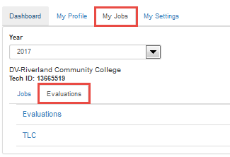

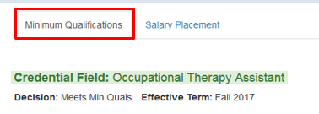

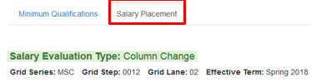

MSCF Evaluation History

MSCF Faculty Credentialing has been migrated from a third-party application to HR Campus. Select historical data currently residing in the third-party product has been migrated into ISRS. Credential evaluation history results may be reviewed by going to the My Jobs tab, then select Evaluation History.

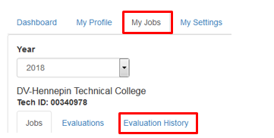

Evaluation Results are separated under three tabs; Minimum Qualifications, Salary Placement and TLC. Select the Expand arrow to display the details of each evaluation.

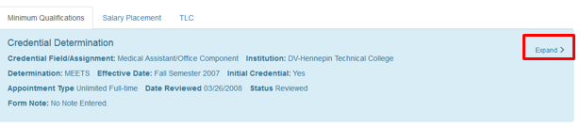

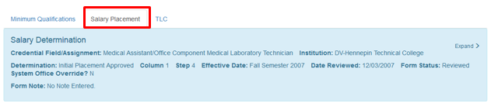

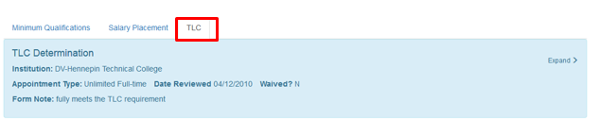

My Jobs

The My Jobs tab provides your job(s) information including State Employee ID, Technical ID, Supervisor, Job Class, Job Class Seniority Date, Bargaining Unit, Appointment Status, Assignment information, Salary details, and Performance Review dates if applicable. You can view past job information by changing the fiscal year. If you have more than one job at an institution, all jobs will be listed and the Technical ID at each institution will be listed.

My Jobs information is for your review only. If you have questions regarding this information, contact your Human Resources Office.

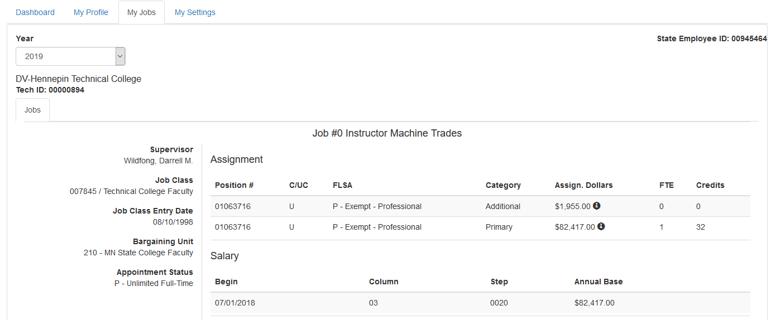

My Settings

The My Settings tab provides a link to manage your StarID, and allows you to set a default institution if you have a relationship with more than one institution.

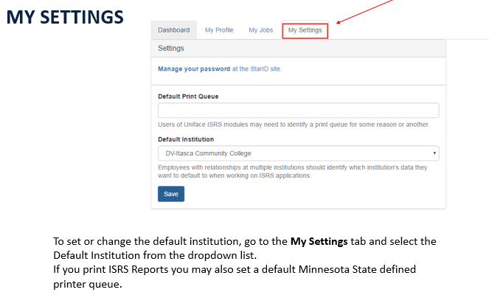

Supervisor Functions

If you are a supervisor, you will have an additional Supervisor Tab on your Dashboard. Supervisor Tools such as Supervisor View, Manage Employee Appointments, Manage TPT Faculty Employment (for supervisors of faculty only), and Delegate Authority will be available under the Supervisor tab. Refer to the [Supervisor Tools Quick Resource Guide](https://mnscu.sharepoint.com/:w:/r/sites/isrsproducts/_layouts/15/Doc.aspx?sourcedoc=%7BE8FAD794-8EC9-43A7-9D14-0890CC3619A8%7D&file=Supervisor%20Tools%20QRG.docx&action=default&mobileredirect=true) (Login using your [StarID@minnstate.edu](mailto:StarID@minnstate.edu) required) for more information on Supervisor Tools.

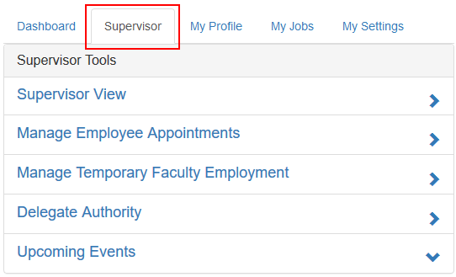

Supervisor View

Supervisor View displays a list of all of your current direct reports at all Minnesota State institutions, with the institutions listed in alphabetical order if applicable. For each employee, it contains job, education, experience, security, emergency contact information, systemwide FTE, and other information that can be used for management and workforce-planning.

Manage Employee Appointments

After a hiring offer is accepted, a supervisor will begin the onboarding process by sending the new employee a welcome e-mail using the Manage Employee Appointments screen, or by assigning a current employee to a job record. A system generated email then provides a process for the newly hired employee to access the Minnesota State information systems to provide information needed to create the employee record, set up payroll and employee benefits.

If the job is being offered to an existing employee, the supervisor will indicate this by selecting an action type of Position Change, Concurrent Position, or Work Out of Class on the Manage Employee Appointments entry page. The employee will not get an email in this scenario but Human Resources will have the information in the system to process the employee further. This list can be sorted by the employee’s name.

Manage Temporary Faculty Employment (for supervisors of faculty only)

A supervisor (or designee) of Temporary faculty will have the ability to identify returning Temporary faculty under Manage Temporary Faculty Employment. Once a Fiscal Year End Date and Year Term are selected, a list of Temporary faculty will load, and a supervisor may select records, update or increase Credit Rates if necessary, and save multiple records. Once saved, Human Resources will have the ability to extend faculty appointments. If an error is made while updating the record, simply click on the “Cancel Update” button and then select Save.

Delegate Authority

A supervisor has the ability to assign certain web-based supervisory tasks to a designee who is an employee or supervisor at the selected institution. Tasks will be limited to the following:

* View Upcoming Employee Events

• Manage Employee Appointments (View Only)

• Manage Employee Appointments

• View Employee Info

• View Employee ISRS Security Roles

• End Employee ISRS Security Roles

• Manage Temporary Faculty Employment

An employee who has been delegated one of the above tasks will then have access to the Supervisor tab, if they didn’t previously, and they will have the ability to view records or complete the tasks on behalf of the supervisor. For more information on Delegate Authority, see the [Supervisor Tools QRG](https://mnscu.sharepoint.com/sites/isrsproducts/Documents/Supervisor%20Tools%20QRG.docx?d=we8fad7948ec943a79d140890cc3619a8&csf=1).

Upcoming Events

In this section, a supervisor has the ability to view or take action on their employee’s upcoming events such as progression increases, completion of probation, annual review, limited appointments or work out of class assignments that are within 60 days of the end date.

You will be notified via a system-generated email if one of your employees has an upcoming event.

NOTE: If your campus is not currently using the Performance Review functionality in HR-Campus, notification will not be sent for performance related events.

Please see the [Employee Event Progression Increase User Guide](https://mnscu.sharepoint.com/:w:/r/sites/isrsproducts/_layouts/15/Doc.aspx?sourcedoc=%7BD54FF00A-FB31-425E-BE47-04AF471A843E%7D&file=Employee%20Event%20Progression%20Increase.docx&action=default&mobileredirect=true) or the [Employee Event Performance Reviews User Guide](https://mnscu.sharepoint.com/:w:/r/sites/isrsproducts/_layouts/15/Doc.aspx?sourcedoc=%7B2358C11A-C0E4-4C4D-97F3-BE904A6DFFB1%7D&file=Employee%20Event%20-%20Performance%20Reviews.docx&action=default&mobileredirect=true) for more details.

Log Out

To log out of Employee Home, click on *Logout* in the top right of the screen.

Tips for using Employee Home

* Create a shortcut, favorite, or bookmark to the page.
* Some applications do not yet return to Employee Home. In this case, the best way to return to Employee Home is to reload the page (this is where your bookmark comes in handy).
* The active institution selected may not transfer into the application you launch. You may have to reselect the institution within the application.
* You can open your applications in a new tab (thereby preserving the Employee Home tab). Right-click on the application link with your mouse and select “Open in New Tab”.

Additional Documentation

To access additional documentation, go to the below links, or go to Help within Employee Home. Log in using your [StarID@minnstate.edu](mailto:StarID@minnstate.edu) and your StarID password required.

[FAQ’s Document](https://mnscu.sharepoint.com/sites/isrsproducts/Documents/FAQ-Employee%20Home.pdf?csf=1)

[Supervisor Tools Quick Resource Guide](https://mnscu.sharepoint.com/sites/isrsproducts/Documents/Supervisor%20Tools%20QRG.docx?d=we8fad7948ec943a79d140890cc3619a8)

Need Help?

For additional assistance, please submit a ticket via the Minnesota State IT Service Desk portal: <http://servicedesk.minnstate.edu/CherwellPortal/MNSO>

The Minnesota State Colleges and Universities system is an Equal Opportunity employer and educator.