SMSU Mustang Admission Portal Instructions

After a student has submitted an application to SMSU they will receive an email from CIE@smsu.edu within 24-48 hours with the subject line “SMSU Application Received” and instructions asking the student to create their Mustang Admission Portal.*
*It’s very important that the student’s personal email is used when creating the StarID and used in the application. The student must have access to the email and this is how we communicate directly with students.

Email to student:
Dear Future Mustang _________,
Thank you for your application to Southwest Minnesota State University (SMSU)! We look forward to having you join us here at SMSU located in Marshall, Minnesota, USA.
YOUR ACTION IS REQUIRED: Click on this link:
https://connect.smsu.edu/account/login?id=9679dd76-07c5-4421-a77b-a06d3cfb4165 to create your Mustang Admission Portal. You must first create an account and login. When you go to the link, you will be asked to enter in this email: (the student’s email appears here). Use this pin number XXXXXXXXX to login your first time. Once you get in, you will be prompted to create your password. Please remember your Username and Password to login often and check your portal for messages and updates. Through your Mustang Admission Portal, you will upload all your documents (high school and college transcripts, national exams, proof of English Language Proficiency, passport copies, financial sponsor form, financial documents, etc.) required for your Admission and I-20 processing.
A $100 non-refundable International Application Processing Fee is required to complete and review your admission application. We cannot provide an admission decision until this payment is received. Details on how to make this payment are available on the International Admission website.
Once all the required documents and the payment have been received, we can promptly process your application for an admission decision. Remember to check your portal often for any updates. We can't wait to meet you!
Warm regards,
The Center for International Education (CIE)

After clicking the link students will see the following screen:
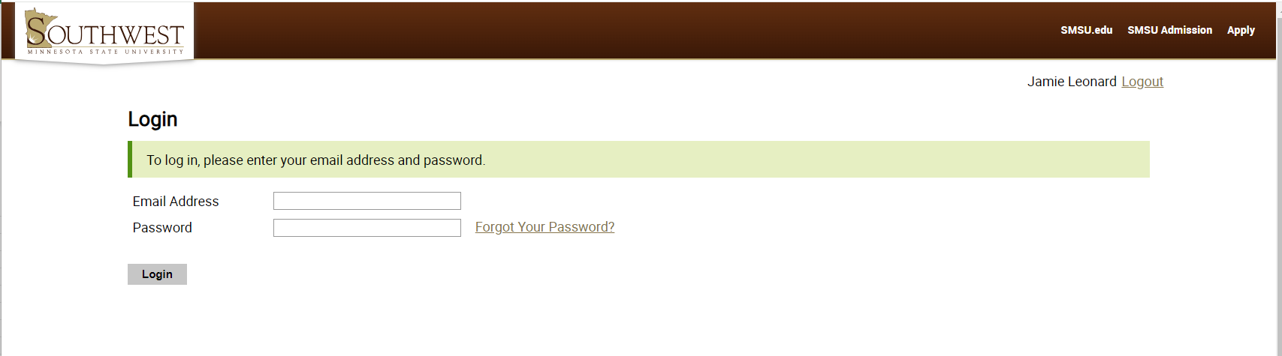
The student needs to enter the email address and Pin number provided in the email as the Password the first time logging in. The student will need to change the password once they login. Please use their same StarID password when setting up their Mustang Admission Portal to make it easier to remember.

UPLOADING DOCUMENTS & TRACKING APPLICATION PROGRESS:
The student will see the following screen (continued on the next page). They will see an Application Checklist along with a list of required documents which will show what documents have been received and which are needed.
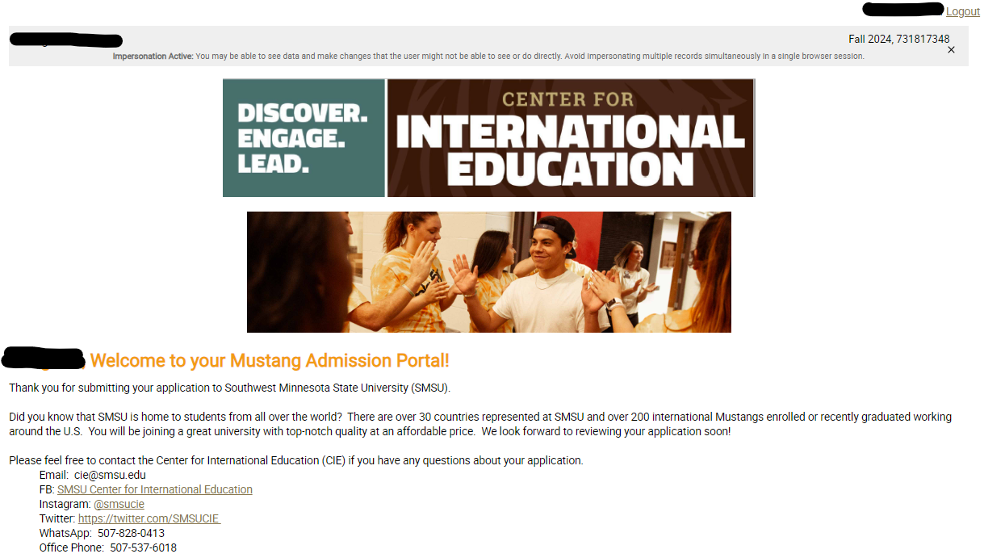
(screen continued on next page)
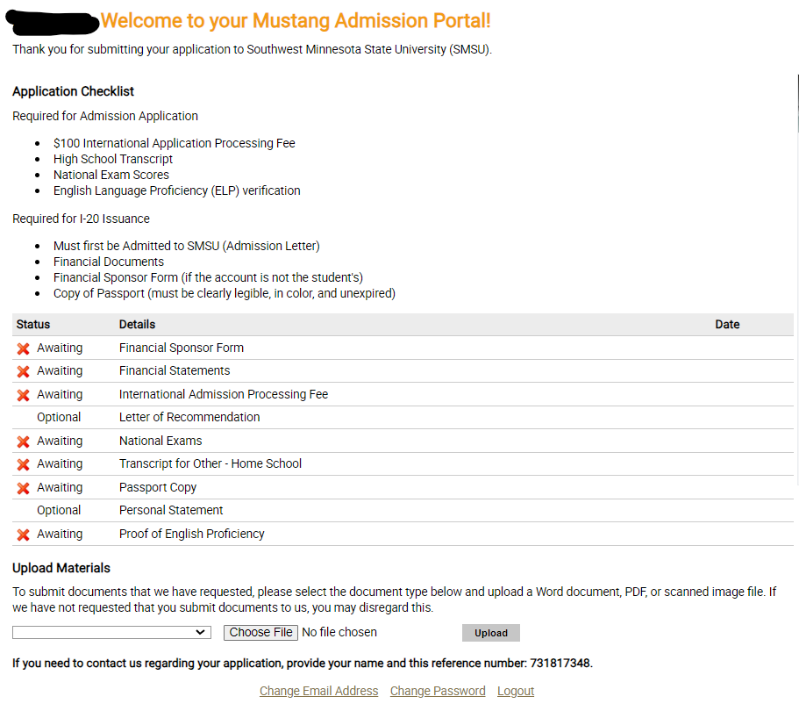
To upload documents the student needs to click the dropdown next to “Choose File” to select the type of document, then click Choose File and finally click Upload.
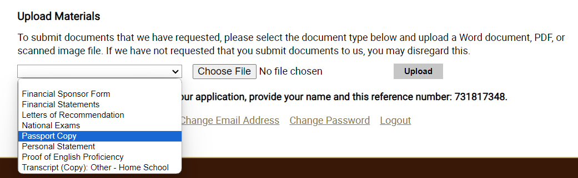
Agent Form
ALL required documents and fees must be submitted before the application will be reviewed and an admission decision made. Agent Forms must be submitted before the application deadline or before the admission decision is made in order to receive commission.

AFTER AN ADMISSION DECISION IS MADE: 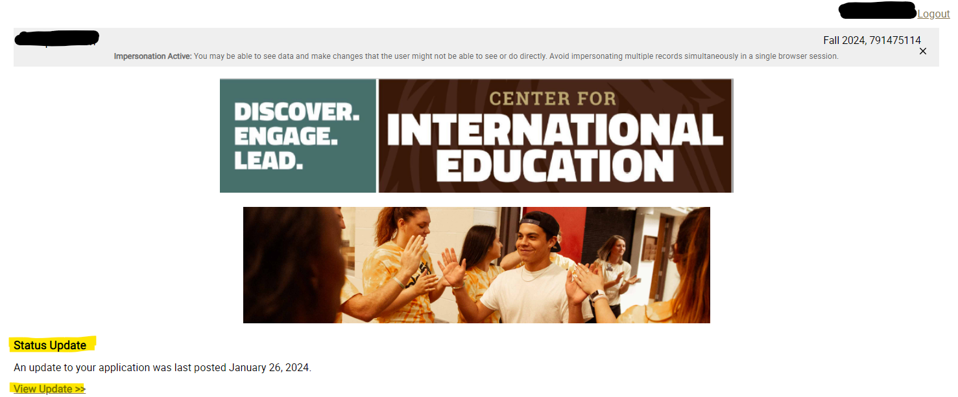
Following an Admission Decision the student will receive an email message to log into their Mustang Admission Portal to view their Admission Letter and/or I-20. See the “Status Update” highlighted. Click on “View Update” to see the admission documents.

At the bottom of the Admission Letter or I-20 that appears on the screen the student will see this information displayed:
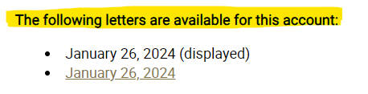
The student can click on the underlined date in order to view the other document.

Click on “PDF” or “Download PDF” in the upper right corner to print each of them out. (See examples on the next two pages.)

