Safety Committee Meeting Minutes Date: 3.12.2025

**Present:** Dave Hemp, Brad Besse

**Injury Update:**

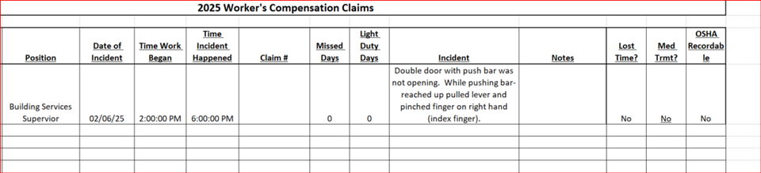

**Drills: None to report**

**Inspections: Science Lab inspections:**

Completed by Mr. Hemp over semester break.

1. One fume hood in ST 256 taken out of service – did not pass airflow test.

Action: Notified maintenance and Dept. Chair. Looking at options

1. Eyewash/safety showers not being tested monthly.

Action: Notified Lab Assistant to please test these monthly.

**COPE Inspection:** Insurance underwriter inspection, I was unable to attend. I provided information regarding security issues, Fire response and emergency response plans.

**Dave’s report:** Light bulb recycling – 833 bulbs recycled, $736.62

NARCAN placed in two AED boxes – RA and SC

**Round Robin:** Brad: Nothing to report